

Hi there.

Thanks for downloading this resource to support early communication and application setup with your clients.

The email template below can be used to request applicant to complete self-assessment. Copy this template to your email software and edit as you see fit.

Brought to you by:

[TEMPLATE]
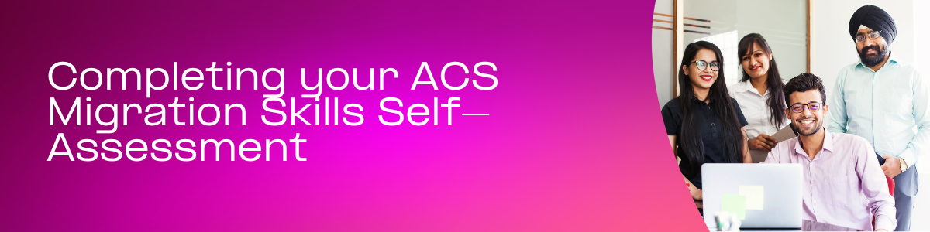
Dear <insert client name>
To continue your ACS Migration Skills Assessment, please complete the Skills Self-Assessment to select your skills and nominate your ANZSCO code/s.

How it works:
- The portal will prompt you to select at least 10 skills based on your qualifications and professional experience
- The portal then automatically suggests ANZSCO code(s) that match
- You can choose to be assessed on up to three of these ANZSCO codes.

The self-assessment should take about 60 minutes to complete. Make sure you read the instructions carefully.

To complete the Skills Self-Assessment:
Log into your Applicant Dashboard

If you have any questions, please let me know.

Kind Regards,

<Insert Your Name and Title>

