

ACS ACCREDITATION MANUAL

Volume 3: Application Template

ACS Accreditation Application Checklist

Before submitting any accreditation application, please ensure that each item in the checklist has been supplied and ticked off

Accreditation Request
School Staffing – permanent staff
School Staffing – casual staff
Institutional Commitment to ICT Education
Student Profile for each degree being accredited
Technological Resources for ICT Education
Quality data such as QILT or recent program reviews
Minutes and Membership of Industry Advisory Board(s)
Actions taken on recommendations from previous accreditation, when there was one
Institutional Policy on GenAI
School or Institutional Requirements for BYOD and technical support
Details of Access to the Learning Management System

For each program (and major, where relevant):

Program Details - code, title on Testamur, Title on Transcript, Campuses, Program Coordinator
Program Objective and Outcomes
Diagram of Program Components and Structure showing prerequisites (in Word not pdf)
Justification of program design including the basis of the design such as curricula from professional bodies or specific BOKs
Professional ICT role intended for the graduates
SFIA skills contributing to that role (in Word not pdf)
Coverage of ICT knowledge table (in Word not pdf)
Subjects contributing to Advanced Knowledge as per Criterion D of the ACS Accreditation Guidelines
Subjects contributing to Integrated and Applied ICT Knowledge and Skills
Preparation for Professional ICT Practice
ICT Program Implementation Pathways, if any
Information, if any, pertaining to any RPL or credit based on previous study and/or experience offered in the program to be accredited
Requirements listed in Section 3.2 of Volume 3 of the Accreditation Guidelines for Satellite and Partner campuses

TABLE OF CONTENTS

1 INTRODUCTION 4
1.1 Terminology 5
2 STANDARD OF APPLICATION 7
3 APPLICATION TEMPLATE 7
1. Accreditation Request 8
2. Institutional Context of ICT Programs 10
2.1 Institutional Commitment to ICT Education 10
2.2 ICT Student Profile 10
2.3 Technological Resources for ICT Education 10
2.4 Monitoring, Review and Improvement 11
2.5 Action from Previous Accreditation 11
2.6 Generative AI 11
3. ICT Program Specification and Implementation 12
3.1 ICT Program Specification 12
Criterion A. Program Design 12
Criterion B. Professional ICT Role and Skills 15
Criterion C. Coverage of ICT Knowledge 16
Criterion D. Advanced ICT Knowledge Addressing Complex Computing 18
Criterion E. Integrated and Applied ICT Knowledge and Skills 18
Criterion F. Preparation for Professional ICT Practice 19
3.2 ICT Program Implementation Pathways 19
3.2.1 RPL and Credit 20
Version History 21
Abbreviated CV 23

1 INTRODUCTION

The Australian Computer Society (ACS) is the authority responsible for the accreditation of professional ICT education programs in Australia.

The ACS is accredited by the International Professional Practice Partnership (IFIP IP3).

The ACS is a signatory to the Seoul Accord. The Accord signatories accord mutual recognition to their respective accreditation schemes for undergraduate and postgraduate (master’s level) (degree) programs for initial professional practice. The Seoul Accord Graduate Attributes have been incorporated within the ACS Core Body of Knowledge (2015, Appendix D). This mapping ensures that a program satisfying the ACS accreditation criteria will satisfy the Seoul Accord criteria and forms the substance of the ACS adherence to the Accord.

The ACS complements the role of Australia's Tertiary Education Quality and Standards Agency (TEQSA) and accredits higher education programs in ICT as a discipline-specific application of the Higher Education Standards Framework (Threshold Standards).

The ACS Accreditation system is specified in 3 volumes:
Volume 1: Accreditation Procedure
Volume 2: Accreditation Criteria
Volume 3: Application Template

This document, ACS Accreditation Manual Volume 3: Application Template has been created to assist educational Institutions to prepare their accreditation application. These guidelines must be read in conjunction with the
ACS Accreditation Manual: Volume 2: Accreditation Criteria.

The key objective of the Application documentation is to provide primary evidence that a program and its institutional context satisfies the accreditation criteria set for assessment of professional ICT education programs. The submitted documentation will be a coherent self-analysis, reporting against the criteria for accreditation. Each criterion must be addressed in a definitive manner and be sufficient for the evaluation panel to form a judgment on it.

The accreditation process is focused on systems and programs that are already in place, not to require their creation. To this end much of the documentation requested should already exist and not require specific research or development. Wherever possible, applicants should link to existing digitally accessible resources rather than replicate them.

1.1 Terminology

For the purposes of the ACS Accreditation Manuals the following terminology is used:

AC The Accreditation Committee of the ACS.

ACS The Australian Computer Society.

AQF Australian Qualifications Framework (https://www.aqf.edu.au).

Accreditation Types
Accreditation recognises programs that prepare graduates for professional practice in ICT. Professional level for initial practice and Specialist accreditation for expertise in a particular specialisation (see Volume 2, Sections 3.2 and 3.3).

CBoK ACS Body of ICT Knowledge.

SFIA Skills Framework for the Information Age, current version
(https://www.sfia-online.org/en).

Bloom’s Taxonomy Anderson, Lorin W (2001) A Taxonomy for Learning Teaching and Assessment: Revision of Bloom's Taxonomy of Educational Objectives Longham.

HESF Higher Education Standards Framework 2021
(https://www.teqsa.gov.au/how-we-regulate/higher-education-standards-framework-2021).

TEQSA Tertiary Education Quality and Standards Agency (https://www.teqsa.gov.au/).

IFIP IP3 International Federation of Information Processing; International Professional Practice Partnership (https://www.ipthree.org).

Seoul Accord Seoul Accord establishes international standards for ICT graduate outcomes and a basis for international recognition of ACS accredited programs (http://www.seoulaccord.org/).

Institution The Higher Education provider that is responsible for, or is applying for, the accreditation of an ICT program.

ICT School That part of the Institution responsible for the education of ICT graduates.

ICT Industry Advisory Board
A body to provide advice on industry requirements of ICT graduates, program content, industry trends and the institution’s interactions with industry.

ICT Industry Liaison
A role in the institution with oversight of industry interaction with a program, including organising ICT Industry Advisory Board meetings and consultations; industry projects, internships and placements; industry guest lectures, visits and so on.

Program A structured set of subjects and/or majors leading to a recognised AQF qualification. In some institutions a program is called a course, or a degree.

Development Plan An institution’s schedule of activities and plans to address any issues that may affect ACS accreditation.

Specialisation An area of the ICT field nominated by the ACS for specialist accreditation (see Accreditation Manual Volume 2, Section 3.3).

Major/ Minor A structured set of subjects which address the complexities of a specific part of the ICT field.

Subject A subject is also known as a course or unit. It is a component of a program in which a coherent body of knowledge taught and assessed as a whole. Where quantification is required, a subject is normally one eighth of one Equivalent Full-Time Student Load (EFTSL) being ‘a measure of the study load, for a year, of a single student undertaking a course of study on a full-time basis’ (https://www.teqsa.gov.au/glossary-terms).

ICT Subject A subject which assesses knowledge from CBoK (see Accreditation Manual Volume 2, Criterion C).

ICT-related Subject A mandatory subject with little ICT content may be considered ICT-related if it is necessary for the achievement of a program's ICT discipline-specific knowledge (Criterion C). The types of ICT-related subjects are:
subjects from 'reference disciplines' providing theoretic or methodological background to ICT - e.g. discrete maths to database, logic to knowledge-based systems, perceptual psychology to HCI, stats to analytics.
subjects from 'application disciplines' subjects that situate or specialise ICT - e.g. health data specification, business analytics algorithms.
An ICT-related subject has a genuine relationship with specific ICT subjects. It needs to be clear how an ICT student's ICT disciplinary knowledge (not capacity in a professional role) is enhanced by an ICT-related subject. An ICT-related subject cannot merely provide a context for ICT to be applied.

Wherever possible the ACS will use the terminology of the institution seeking accreditation, however, for consistency, the above terminology is used throughout the Accreditation Manual.

2 STANDARD OF APPLICATION

The Seoul Accord, an agreement between signatory countries, recognises comparability of accreditation systems and standards for professional ICT programs. The Accord is maintained through an ongoing program of mutual inspection and validation. It is possible at any time that the process of ACS accreditation of programs within any Australian institution may be subject to scrutiny and/or participation by observers from other Seoul Accord signatories.

Applications must be of a suitable standard for international audit. If the initial documentation is not considered to meet the following guidelines, the Institution may be asked to resubmit before a visit is scheduled.

3 APPLICATION TEMPLATE

Full accreditation applications must be submitted a minimum of eight weeks before any planned accreditation visit. Before submitting your application, ensure that you have completed every section of the attached checklist and submit the checklist with your application. Failure to submit a complete application on time, will lead to delays in accreditation.

The Template below is recommended as a means of presenting the data needed for accreditation.
The template contains:
- headings matching the criteria specified in Volume 2
- blue italicised text providing explanation and suggestions to help in completing each section.
To use the template, delete the blue italicised text when you have completed the section.

As the Accreditation Panel may at any stage request further information, provide only what the template asks for.

1. Accreditation Request

Institution: | Provide the full name under which the Institution operates and confers the qualifications resulting from the programs to be accredited.
Name of Institution
CEO
Institution Address
Telephone
Institution Web Site

ICT Teaching entity: |  | Provide details of the college/faculty/school/department structure responsible for offering the program(s) for accreditation. Room is provided to allow a three-level description of the organisation entity - please provide the type of entity (e.g. faculty or department) and its name (e.g. School of Computing and Mathematical Sciences).
Level 1
Level 2
ICT Teaching Entity
ICT Entity Web Site
Head, ICT Teaching Entity
Address
Telephone
E-mail address
Industry Liaison Co-ordinator

Programs: | Provide a list of programs submitted for accreditation.  Level refers to the level of award (e.g. AQF 7, AQF 9).  Type refers to the ACS accreditation sought (Professional, Specialist)  If applying for specialist accreditation for a program, refer to the requirements listed in Volume 2 of the Guidelines.
Title of Program |  | Campus | Level | Type

Institution Contact: | Provide details of the primary contact and person responsible for this application.
Name
Title
Address
Telephone Number(s)
E-mail address

School Staffing

Provide the following staffing table for the main campus. If the information is provided in the online staff directory for the ICT School then that may be provided instead.

Permanent/Contract Staff only (i.e. non casual or sessional – see below)

Name ordered by Family Name | Level  (i.e. A-E) | Highest Qualification | Permanent  /Contract | FTE | 1-3 areas of expertise  (not names of subjects taught) | Teaching campus (satellite or partner) if not the main campus
…..add as many rows as needed

Permanent Staff CVs

Provide a link to the school’s staff directory, where it exists or add a link to the individual’s online cv with their name, e.g. Jane Doe.

Casual or Sessional Staff

Where casual or sessional staff are lecturing or in charge of hybrid/blended learning classes as opposed to just taking tutorials or laboratories, fill in the table below.

Casual or Sessional Staff

Name ordered by Family Name | Highest Qualification | FTE | 1-3 areas of expertise  (not names of subjects taught) | Teaching campus (satellite or partner) if not the main campus
…..add as many rows as needed

Casual or Sessional Staff CVs

Provide a CV for each such staff member on the TEQSA staffing template (see attachment 1) or CUAP (NZ) or AQA (NZ).

2. Institutional Context of ICT Programs

This section of the template identifies the evidence which would allow the Accreditation Panel to assess the institutional context for ICT Education. Where the institution provides links to documents or information, please ensure that the appropriate permissions to the relevant sections of the institution’s systems are available to ACS panellists.

2.1 Institutional Commitment to ICT Education

Brief Strategic Statement of Institutional Support

Linking to an Institution mission statement and strategic plans may provide evidence of the Institution’s long-term commitment to ICT. If necessary, a statement from the institution's president or CEO may be needed.

ICT School Planning and Review

Existing documents embodying the School’s strategic directions for ICT education, industry engagement, research and other professional activities are useful evidence.
Include the Development Plan if one was created during the School's self-analysis (see Accreditation Manual Volume 1 Section 3).
Link to documents associated with the most recent School or curriculum review.

The ICT School – Structure and Institutional Context

In order for the panel to better understand the larger context of ICT programs, outline the organisational structure of the School, including management roles and incumbents, and briefly how it interacts with the institutional structure (Faculty and Institutional committees, etc).

Educational Location and Partnerships

List all campuses at which this program is offered. Include online as a separate campus.
If the program is offered by a third party in a partnership, please also supply contact details for the person in the partner organisation responsible for the institution’s ICT programs.

2.2 ICT Student Profile

While there are no specific ICT accreditation criteria beyond HESF Section 1.3, the panel needs an understanding of the student profile or the New Zealand AQA expectation of reviews of courses and program data. Link to an indication of the EFTSL in each program by campus and data concerning student progression (admission and graduation data). The data should indicate student gender and whether they are domestic or international.

2.3 Technological Resources for ICT Education

Identify specific ICT facilities, including laboratories, specialised technology and software in active use for teaching and the level of student access to them.
Show how these facilities are related to current industry practice.
Indicate the technical support for these facilities and the training for staff.
Link to school and/or institutional policies regarding the use of technology in education.
If the school/institution relies on BYOD for teaching ICT, provide a link to the BYOD specifications and information re the technical support available for staff and students.

2.4 Monitoring, Review and Improvement

For Australian institutions, link to QILT data for each program and internal data used in program monitoring.
Link to the mechanism(s) for seeking advice from the ICT industry, alumni, the community and professional bodies. Link to agendas and minutes of meetings of the ICT Industry Advisory Board demonstrating their input into program.
Link to recent internal reviews of the ICT School and its program. Any responses to other accrediting bodies including TEQSA, CUAP (NZ) or AQA (NZ) may be useful.

2.5 Action from Previous Accreditation

Provide a response to the recommendations of the previous accreditation, when there was one.

2.6 Generative AI

Provide a link to the institution’s policy on GenAI and/or to the ICT School’s, if one exists.

3. ICT Program Specification and Implementation

This section of the template identifies the information that specifies each program. In this section of the template briefly demonstrate how the program has been structured to develop the Professional Knowledge, Skills and Application of Knowledge and Skills required to achieve the program's ICT professional objectives. This should normally be available as a link to internal institution documents when the program was approved.

Prepare one response for each program.
Where there are multiple majors within a program which target different professional roles,
prepare one specification for each major. If the program is also offered without a major, prepare a specification for that also.

Program Details

Program Code:
Award Title on Testamur:
Award Title on Transcript:
Campuses where offered:

Personnel

Program Coordinator:

Access to Documents and Teaching Materials

Provide a link to the institution-approved document(s) that specify the program and each subject including, or as well as, all assessment items and how they are matched to subject learning outcomes. For most institutions, this will be in the Learning Management System.

Provide read-only, auditor level access to the Learning Management System. This access is used to review and assess the teaching and learning as it applies to accreditation criteria. The access should cover all subjects being taught so is usually to the last two semesters. Access should not be provided for the current semester.

3.1 ICT Program Specification

Criterion A. Program Design

Program Objective and Outcomes

Provide a link to the institution-approved document(s) that specify the program's approved objectives and learning outcomes (including the institution’s graduate outcomes), entry requirements and structure. This will usually be the program website but may be an online handbook.

Program Components and Structure

Link to, or if necessary, create, information that identifies:
- mandatory ICT subjects, elective ICT subjects and non-ICT subjects (perhaps use colour coding)
- prerequisite knowledge links (both hard prerequisites and assumed knowledge).
A sample diagram is:
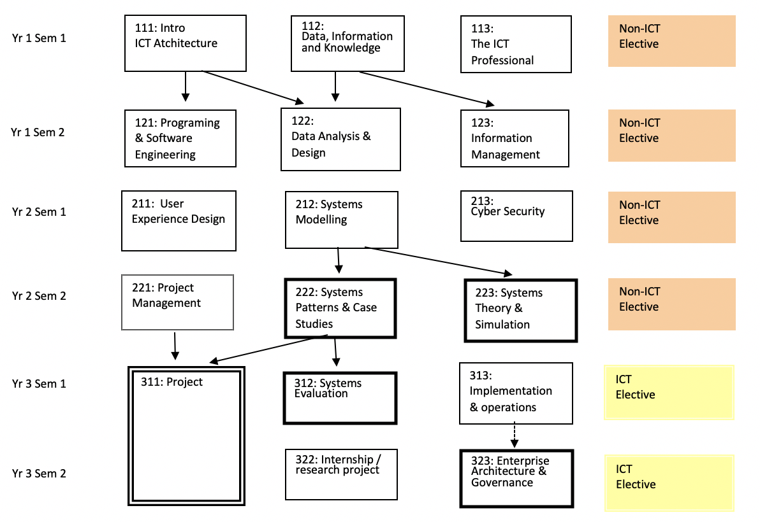

SAMPLE

In this sample the darker border on boxes denotes Advanced Subjects (see criterion D) and
the double border on boxes to denote Integrated and Applied subjects (criterion E). Arrows show prerequisites, dotted arrows, if any, show assumed knowledge.

Provide a list of any mandatory ICT subjects that may be sourced from external providers (e.g., through articulation arrangements, partnerships, etc.)

Justification of Program Design

a) Show the coherence of title, objectives, components and structure that align with the attributes of the graduate and the student intake. Explain how the assessment of individual subject learning outcomes aggregate to ensure that learning outcomes for the program as a whole are met.

b) Provide a link to documents (perhaps a recent program review) that justifies the program. In particular, how the program:
- is related to needs of future stakeholders including the target ICT industry and the community
- responds to international curricula (see also Criterion C)
- compares with programs of a similar nature available nationally or internationally
- embodies good program design practices from current academic literature on ICT education
- embodies trends in professional practice.
Link to any further documents about the program that may assist the panel to evaluate its fit with its professional environment. This may include ACM, IEEE, etc curricula and other related bodies of knowledge, e.g., SWEBOK, BABOK, CYBOK, etc.

Criterion B. Professional ICT Role and Skills
For each named major or specialization in the program (or for the program itself where there is no major), identify the primary ICT professional role that a graduate is equipped to perform on graduation. While aspirational roles (such as CIO, project manager) have a purpose in indicating a career path for graduates, the professional role identified here will be one to which the graduate is immediately suited. If necessary, one further role may be listed.

Useful sources describing professional roles include:
Skills Framework for the Information Age
https://sfia-online.org/en/tools-and-resources/standard-profiles
European ICT Professional profiles (e-CF)
https://itprofessionalism.org/about-it-professionalism/competences/ict-profiles/
ACS Digital Skills White paper
https://www.acs.org.au/insightsandpublications/reports-publications/demand-impacts-tech-digital-skills.html
Australian Public Service Digital Career pathways
https://data.gov.au/data/dataset/aps-digital-career-pathways
Queensland Government Career Streams (2017)
https://www.qgcio.qld.gov.au/information-on/workforce-planning/ict-career-streams
ACS Digital Pulse
https://www2.deloitte.com/au/en/pages/economics/articles/australias-digital-pulse.html
ANZCO ICT Occupations
https://www.acs.org.au/content/dam/acs/acs-skills/ANZSCO_Code_Information.pdf
If an ANZCO ICT Occupations Code has been Identified, identify it.

The School's ICT Industry Advisory Board will be an important source of advice.

The SFIA skill set is useful as a specification of skills and levels of skill in ICT. There are other schemes such as the European e-Competence Framework (http://www.ecompetences.eu) that may be used.
In the table below:
Identify 1 -3 primary SFIA skills needed for the above professional role (at least one skill must be assessed at SFIA Level 3 or above).
Map each SFIA Skill to the most significant mandatory subjects excluding foundation subjects but including advanced subjects (criterion D) that assess it to demonstrate skill development.

B. ICT Skills for Professional Role | ROLE:
SFIA Skill Code | SFIA level | Subject Code & Title

Note 1. Ensure that the skills selected are core to the professional practice in ICT, not all SFIA skills are considered to be integral parts of the ICT discipline.
Note 2: The upper-level SFIA skills require organisational and managerial activity and experience that cannot normally be gained in an academic subject. For example, a claim that an undergraduate second-year subject in web development is at SFIA level 5 would be difficult to support. Equally, some SFIA skills that may be important for your program do not have lower level specifications. In this case interpret the general description of SFIA level to arrive at a level you think appropriate).

Many institutions map most of their subjects to SFIA for internal QA purposes, for packaging subjects as modules for industry professional development, micro-credentials and other uses. If that is the case, please link to that mapping rather than re-producing it.

Criterion C. Coverage of ICT Knowledge

The ACS Body of ICT Knowledge (CBoK) identifies three knowledge categories that are the hallmarks of an ICT professional - Professionalism as it applies in ICT, Core ICT Knowledge, In-depth ICT Knowledge. Each of these categories has a set of major topics, and each of these in turn has a set of minor points that aim to explain and illustrate the scope of the major topic.

The ACS CBoK is used for different purposes in a range of ACS Standards Systems. The Accreditation System requires a graduate to have a coherent breadth of ICT knowledge. A graduate who is unable to discuss each major ICT topic and recognise cases and examples of it (Introductory level knowledge - Bloom's level 1 & 2) is not considered by ACS to be prepared for ICT professional practice. This does not mean that all the minor, illustrative points in CBoK need to be covered. The appropriate depth of coverage is largely determined by the objectives of the program and the professional role the program addresses (but see notes a) to c) below).

To demonstrate breadth of ICT knowledge, use a grid (see sample below) to associate major topics from the CBoK with the most significant mandatory subjects that assess that knowledge. Identify a maximum of 3 subjects in 'Professional' and 'Core' columns. No column may be empty.
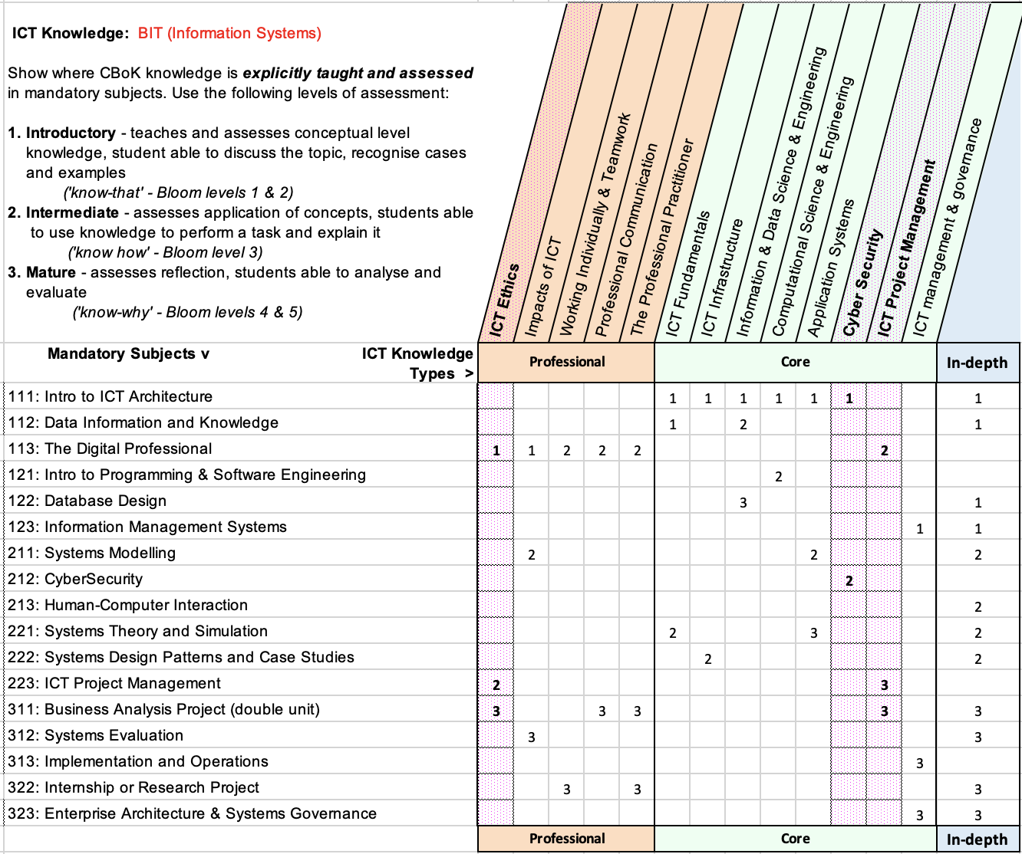

SAMPLE

a) CBoK Professional Knowledge - ICT Ethics is considered a key professional attribute (see the ACS Code of Ethics). Ensure that it is taught and assessed at least at intermediate level (Bloom level 3).
Skills in working 'individually and teamwork', and 'professional communication' should also be Intermediate level, Bloom level 3.

b) CBoK Core Knowledge - Knowledge of ICT Project Management and Cyber Security are considered key professional attributes. Ensure they are taught and assessed at least at Intermediate level, Bloom level 3.

c) CBoK In-Depth Knowledge - The in-depth column demonstrates the building of knowledge within the relevant ICT discipline and towards the advanced subjects (Criterion D). Identify external disciplinary curricula and bodies of knowledge to provide a justification for the CBoK In-Depth Knowledge being taught. See the CBoK for a range of resources.
The CBoK section 3.3 describes the relationship between Core ICT knowledge and ICT related Bodies of Knowledge, including the Data Science BoK, the Business Analysis BoK, etc. No related bodies of knowledge fully cover the CBoK, so a program based solely on a related body of knowledge will not in itself satisfy the breadth of ICT knowledge requirements (Criterion C). In addition, many related bodies of knowledge contain subjects beyond the scope of CBoK (for example, Statistics in the case of Data Science BoK, Organisational Behaviour in the case of Business Analysis BoK) and these subjects do not count towards the required volume of ICT knowledge (Criterion A).

Criterion D. Advanced ICT Knowledge Addressing Complex Computing

Review the requirements for advanced ICT knowledge to address complex computing in the Accreditation Manual, Volume 2, Criterion D.

In the table below:
Identify subjects that are assessed at an advanced level that are targeted specifically at the professional role identified for this program (exclude the advanced subjects used in Criterion E).
Identify the assessment item(s) that assess ICT knowledge at an advanced level e.g., at least Blooms level 4). Note that quizzes, exams, practicals, etc do not count. The assessment item must involve the solution of a complex problem with few directions as to the solution approach and would typically have a weighting of at least 25% of the subject total
Then explain in no more than 50 words which Seoul Accord criteria of complex computing are addressed by each such assessment item (see Criterion D in Volume 2 of the Accreditation Manual).

D. Advanced ICT Subjects Addressing Complex Computing
Subject Code & Title | Assessment Item | Complex Computing Criteria met

Criterion E. Integrated and Applied ICT Knowledge and Skills

Review the requirements for integrated and applied ICT knowledge in the Accreditation Manual, Volume 2, Criterion E.

Identify the advanced subject(s), often a capstone, that provide and assess the integration of knowledge and skills specifically targeted at the professional role identified for this program.

E. Integrated & Applied ICT Knowledge
Subject Code & Title | Notes in support of Claim

Criterion F. Preparation for Professional ICT Practice

Show, in no more than 100 words, how the program develops a well-rounded professional with respect to the attributes listed in the Accreditation Manual, Volume 2, Criterion F. This particularly refers to opportunities for WIL, internships, etc.

3.2 ICT Program Implementation Pathways

In this section of the template, link to any information needed to explain and justify any relevant aspects of the program implementation pathways referred to in
Section 3.2.2 of the Accreditation Manual Volume 2 Accreditation Criteria.
This typically refers to undergraduate degrees which may enrol students in higher years based on students’ previous studies in partner feeder programs.

Educational Locations and Partnerships

In the following, Satellite Campus refers to a campus of the institution located separately from the main campus but with the institution’s name and with academic staff appointed by and employed by the institution whose programs are being accredited. Partner Campus refers to a third party organisation running programs for the institution. Typically, academic staff are appointed and employed by the partner but approved by the institution whose programs are being accredited.

For each additional location (other than the main campus) where a program is offered, provide information on the following aspects:
- For a Satellite Campus: name of location
- For a Partner Campus:
- Name of location(s) and partnership organisation
- Nature of relationship with main institution – include relevant dates for collaboration
- Model of program delivery e.g., on shore/off shore combination (3+1), fully off shore (4+0), etc.
- Is the partner organisation an accredited educational institution? E.g., TEQSA, other government body.
- QA roles and processes that are in place for the program delivery
- Roles and processes for employing local staff, including types of employment contracts
- Program operational handbook which determines each party’s roles and responsibilities
- Roles and processes for assigning teaching staff to subjects, included (if relevant) subject coordinator, moderator, and lecturing staff (lecturers and tutors)
- Available subject offerings and program requirements: are all subjects (including electives) offered at each location, are there additional/different program completion requirements?
- Timing of subject offerings and assessment tasks: are they offered at the same time, at different times, or a mix of the two?
- Roles and processes for setting assessment in the course including assignments and exams
- Roles and processes for moderating assessed items and results
- Roles and processes for student support for subjects and more generally
- Roles that staff from each location have in curriculum development and review
- If this information has not been provided elsewhere in the submission, number of students enrolled (commencing and continuing) and number of completions in each program at each location

In addition, for each program offered at each additional location, provide a list of staff who teach into the program (in the same format as for the main campus) and provide a link to a short CV for each of these staff members.

3.2.1 RPL and Credit

Describe the arrangements, if any, available for Recognition of Prior Learning and/or Credit based on previous studies and/or experience. Some special cases:

- Many institutions have noncognate Masters of 16 subjects. Most offer 4 subjects of credit for previous cognate studies (AQF level 7). Occasionally, there are some free electives in the remaining 12 subjects. The maximum free electives that would be accepted in this particular case would be two. The ACS will examine the remaining ICT subjects carefully to ensure that they meet criteria a, b, c in Section 3.2.2 of Volume 2 of the Guidelines
- Where a Masters program has an integrated Graduate Diploma and students enter the Masters with 8 subjects of credit from the Graduate Diploma, then all of the subjects in the Graduate Diploma/Masters may be used to meet Criteria B-E
- Occasionally, for Masters, institutions offer 8 subjects of credit for cognate Honours (AQF level 8). The ACS will examine the remaining ICT subjects carefully to ensure that they meet criteria a, b, c in Section 3.2.2 of Volume 2 of the Guidelines
- Any other special case will be dealt with on an individual basis provided the institution can demonstrate to the ACS how the subjects being taught in the degree to be accredited meet criteria a, b, c under Articulation Arrangements in Section 3.2.2 of Volume 2 of the Guidelines

In each case, institutions must also abide by TEQSA guidelines on credit and RPL
https://www.teqsa.gov.au/guides-resources/resources/guidance-notes/teqsa-and-australian-qualifications-framework-questions-and-answers
and TEQSA guidelines on nested courses
https://www.teqsa.gov.au/guides-resources/resources/guidance-notes/guidance-note-nested-courses-study

TEQSA guidelines on joint and dual awards may also be relevant in some cases
https://www.teqsa.gov.au/guides-resources/resources/guidance-notes/guidance-note-joint-and-dual-awards

Version History

Date | Document  Version | Revision History (reason for change) | Author /Reviser
2 Oct 2013 | 1.0 | Creation of original document
4 Apr 2014 | 1.1 | Formatting updates | Graham Low
10 Nov 2015 | 1.2 | Changes to section 3.2.3 | Graham Low
19 Feb 2016 | 2.0 | Version update in alignment with CBOK release | Berny Martinez
31 Jan 2019 | 4.0 Pilot | Complete revision: clarified criteria, aligned with TEQSA, simplified application | Craig McDonald
12 Aug 2019 | 4.2 Pilot | Minor revisions – interim pilot feedback | Craig McDonald
15 Dec 2019 | 5.0 | Incorporate feedback from pilot | Craig McDonald
15 Sep 2020 | 5.1 | Incorporate feedback – minor edits | Craig McDonald
30 Aug 2021 | 5.2 | Data Science specialisation – minor edits | Craig McDonald
30 Sep 2021 | 5.3 | Align with revised CBoK, refine specialisations | Craig McDonald
30 Dec 2022 | 5.3 | Minor edit to Criterion C | Craig McDonald
4 Apr 2024 | 5.4 | Minor edits to terminology, formatting of responses | Jenny Edwards
20 Aug 2024 | 5.4 | Minor addition re RPL and Credit | Jenny Edwards
 | 5.4.1 | Minor edits re BYOD | Jenny Edwards

APPROVALS

Date approved | Version: | Approved By | Date in force | Next Review Date
15 Dec 2015 | 1.2 | Professional Standards Board | 15 Dec 2015 | n/a
19 Feb 2016 | 2.0 | Professional Standards Board | 19 Feb 2016 | n/a
1 Feb 2019 | 4.0 Pilot | Management Committee | 22 Feb 2019 | n/a
12 Aug 2019 | 4.2 Pilot | Rupert Grayston, Director PSAS | 13 Feb 2019 | n/a
29 Jan 2020 | 5.0 | Rupert Grayston, Director PSAS | 1 Feb 2020 | n/a
15 Sep 2020 | 5.1 | Rupert Grayston, Director PSAS | 15 Sep 2020 | n/a
30 Aug 2021 | 5.2 | Siobhan Casey, A. Director PSAS | 30 Aug 2021 | n/a
30 Sep 2021 | 5.3 | Siobhan Casey, A. Director PSAS | 30 Sep 2021 | n/a
30 Jan 2023 | 5.3 | Rupert Grayston, Director, Capability | 30 Jan 2023 | n/a
16 Apr 2024 | 5.4 | Rupert Grayston, Director, Capability | 16 Apr 2024 | n/a
30 Aug 2024 | 5.4 | Rupert Grayston, Director, Capability | 30 Aug 2024 | n/a
 | 5.4.1 | Rupert Grayston, Director, Capability |  | n/a

Custodian title &  e-mail address: | Rupert Grayston, Director, Capability  Rupert.Grayston@acs.org.au
Responsible Business Group: | Capability
Distribution: | Public document
Content Security: | N/A.

Attachment 1
TEQSA CV template





Abbreviated CV
Sections relating to academic experience only need to be completed for individuals with academic roles.

1. Title and name
Title | First and other names | Last name

2. Position and academic leadership responsibilities (current and previous)
Position(s) | Academic leadership responsibilities (if any)
3. Completed academic qualifications
Full name of award | Subject/major area | Full name of awarding institution and year of award (if an overseas institution, also include the country)

4. Teaching experience (previous seven years)
Teaching period  (from most recent) | Field of study area/course title | Name of organisation/institution and, if an overseas institution, the country

…

5. Relevant employment/experience
Note: Provide a brief history of the employment and/or other experience (if different from 2 & 4 above) which is relevant to the current higher education role and field of education.
Employment period | Name of employer | Position title | Relevant duties

6. Other relevant information (including professional and/or honorary memberships, directorships and related scholarly activities)

7. Research supervision experience (if supervising research candidates)

8. Publications (scholarship and research outputs)
Provide link to Google Scholar or University publication records, if relevant

